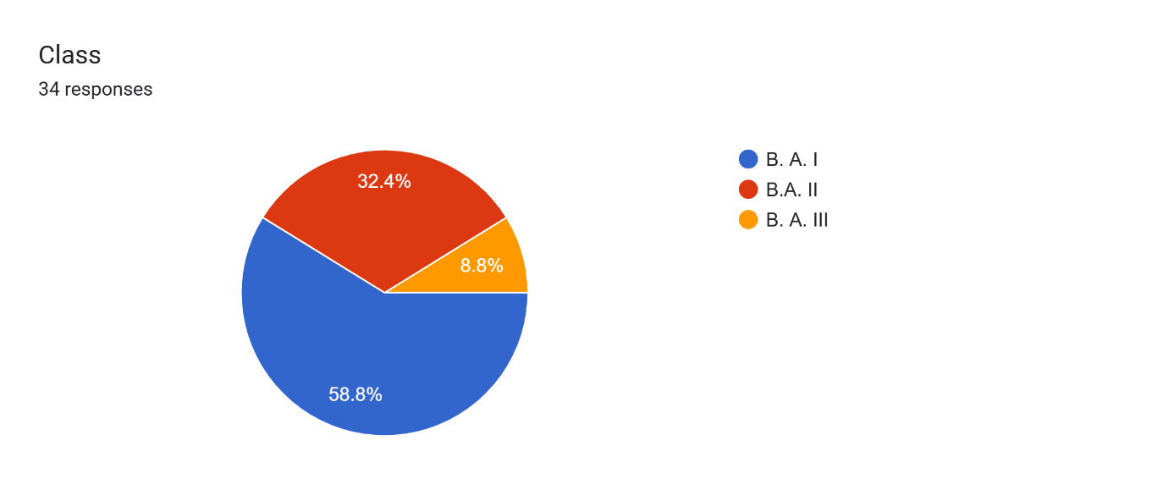

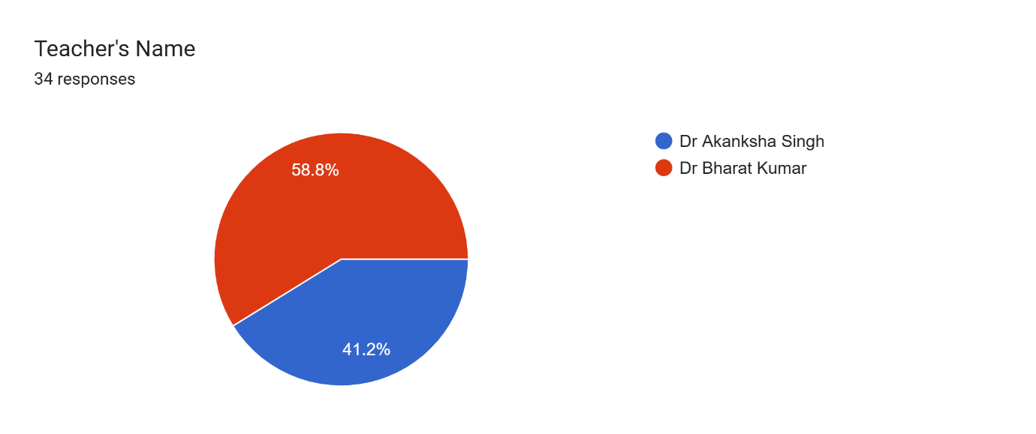

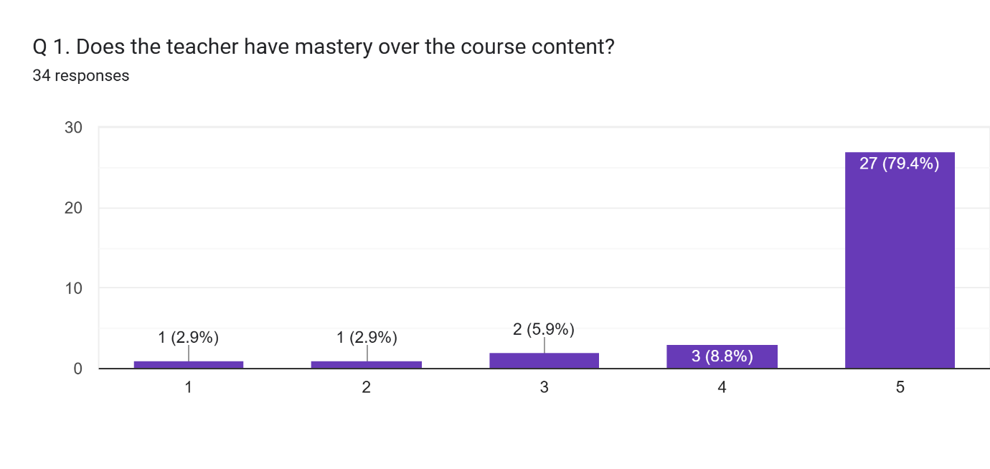

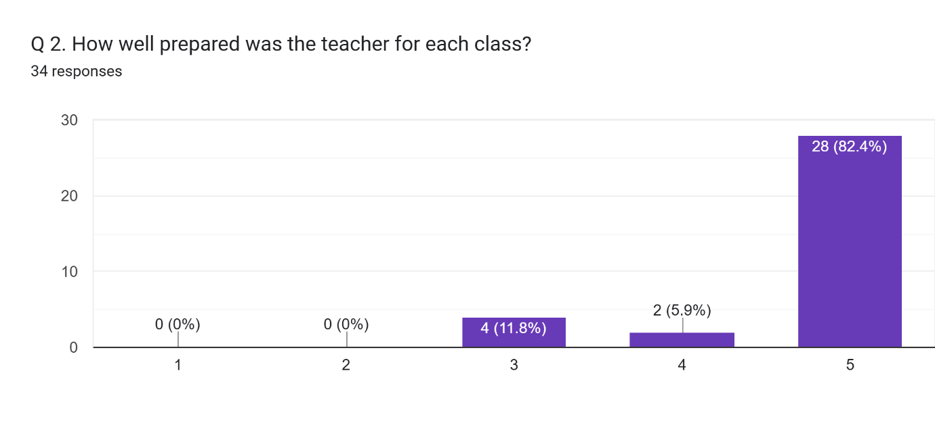

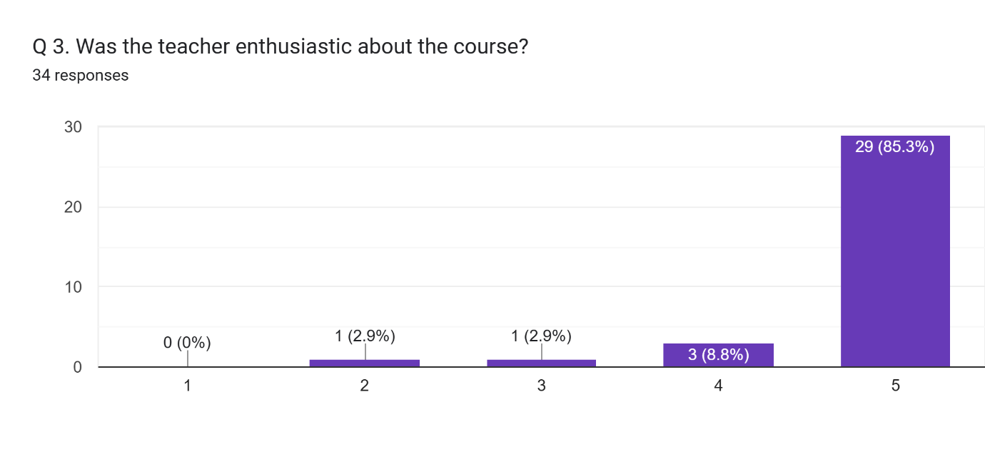

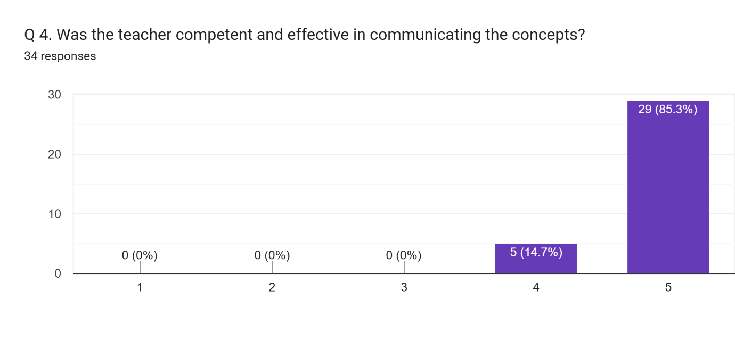

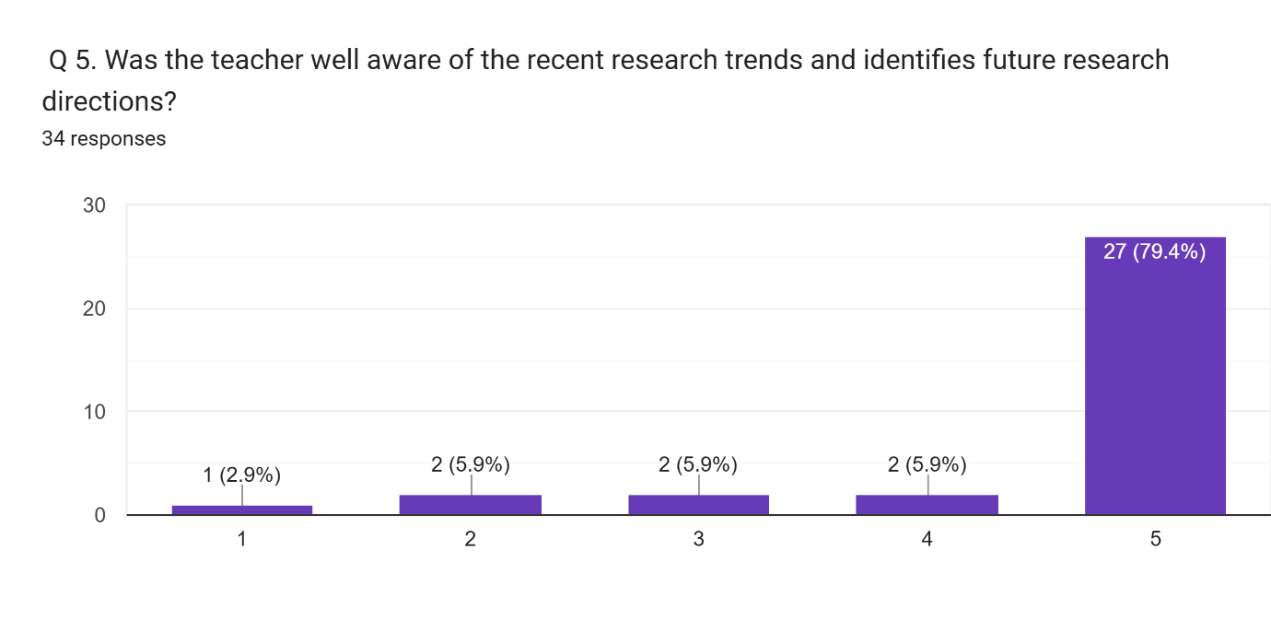

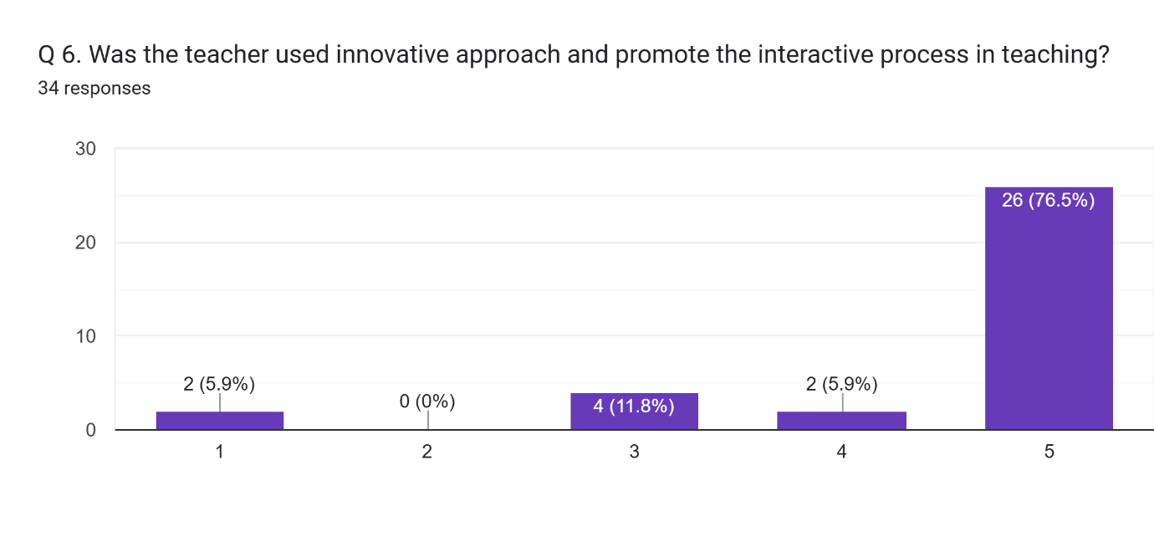

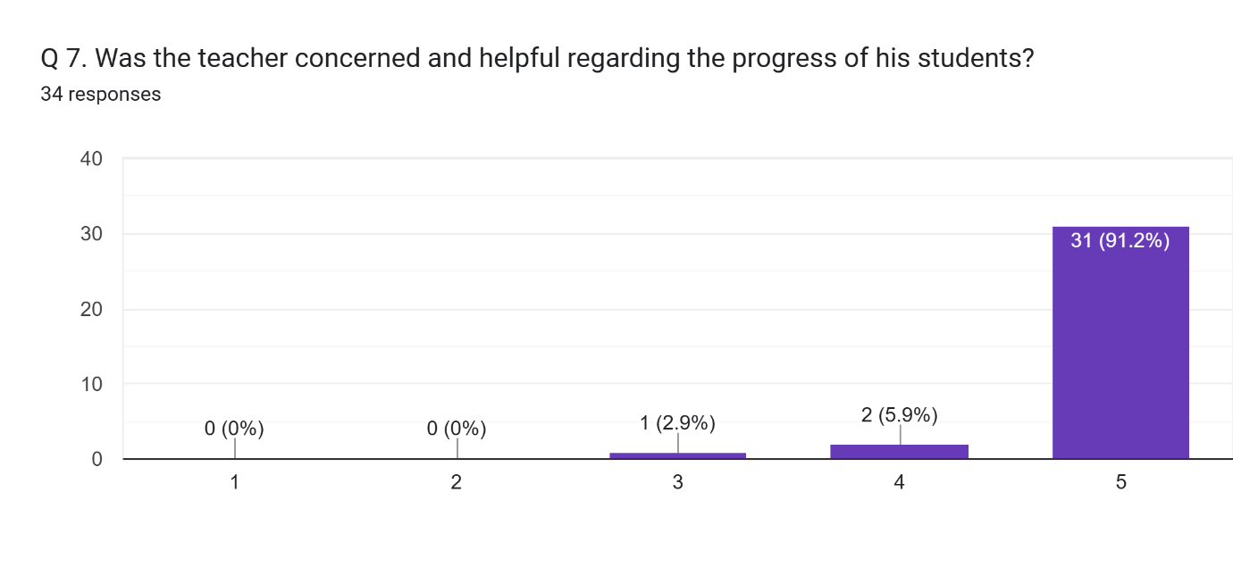

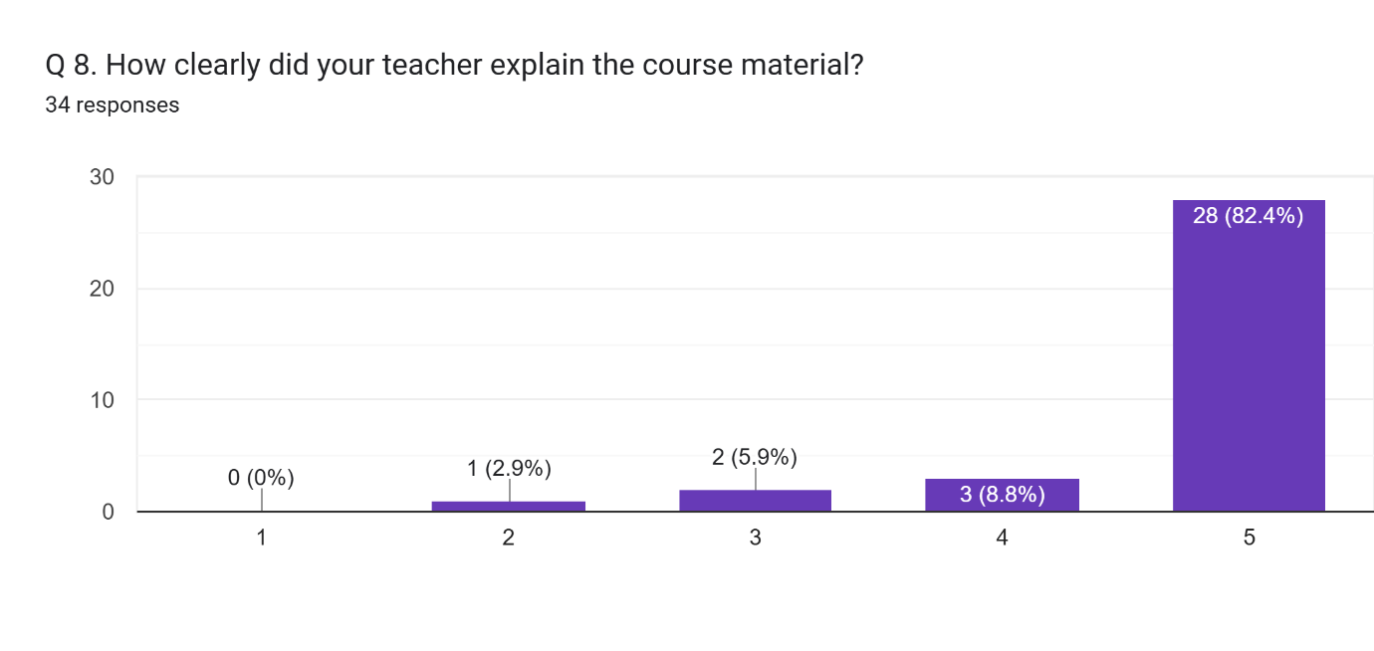

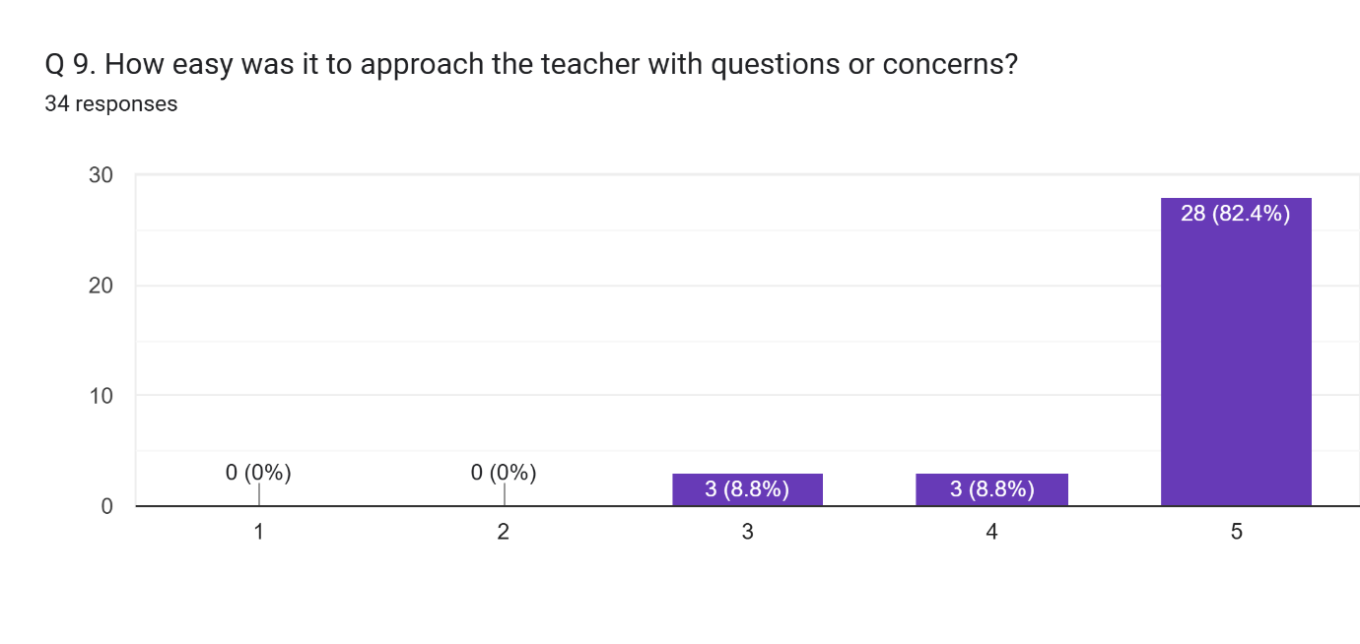

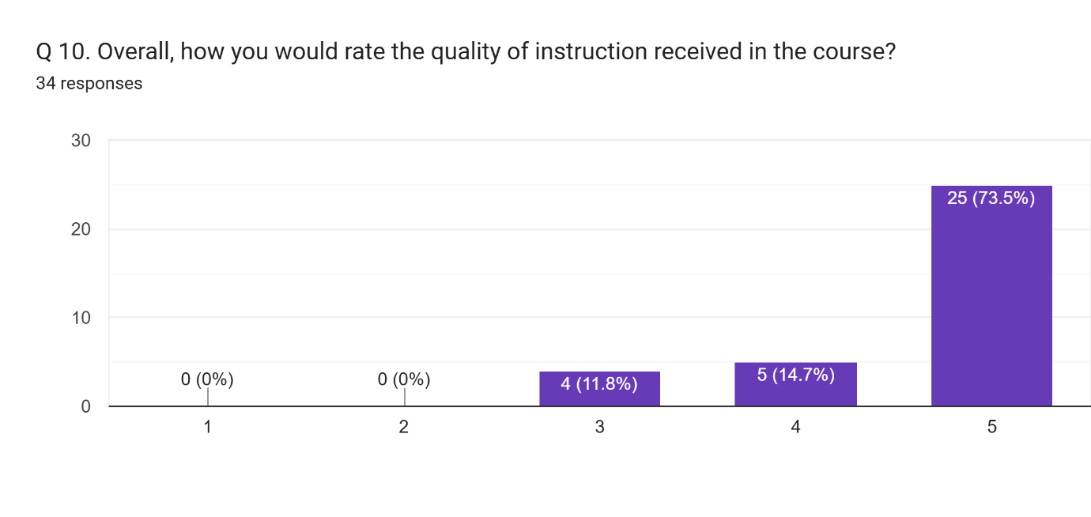

Any other comment which you would like to mention (Please write in space provided here).  
13 responses

Not mention

All Sanskrit teacher,s are very helpful

Very helpful teacher

Very supporting teacher in college

Very good

Study

All good

When we work hard and ask the teacher about any task then it can be understood easily.And we should feel free to ask any questions from the teacher.

Notmention

Sir has explained every thing very clearly to the children, he is the best teacher.

Sir has tried his best to make the children understand everything clearly, hence he is the best teacher.