**Academic Session 2023-24**

**Students Feedback on Resources**

**Collected and Analyzed by Dr. Jharna Malviya**

**B.A.**

B.A. (Students Feedback on Resources)

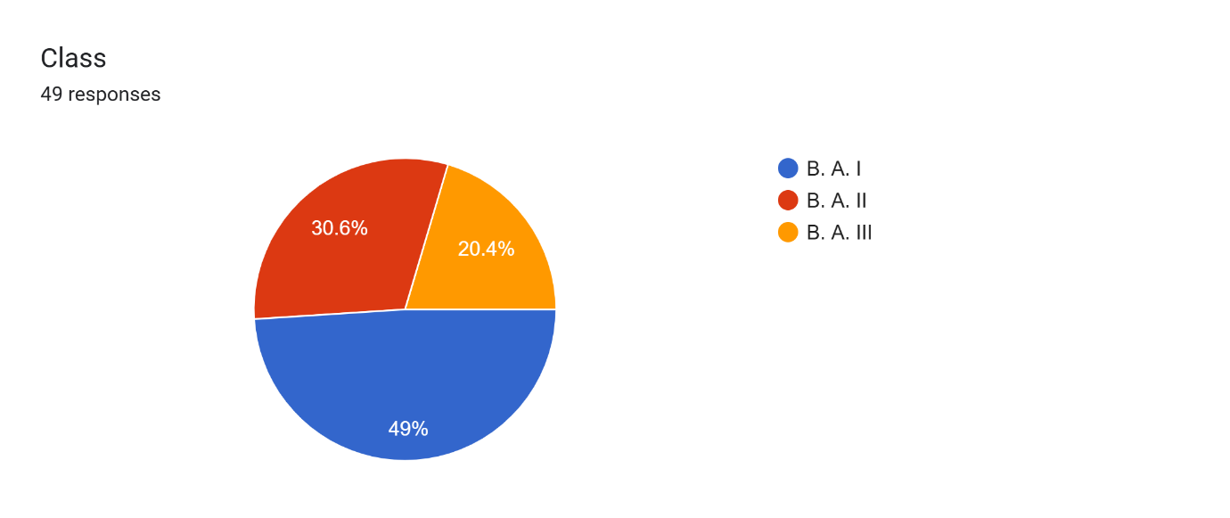

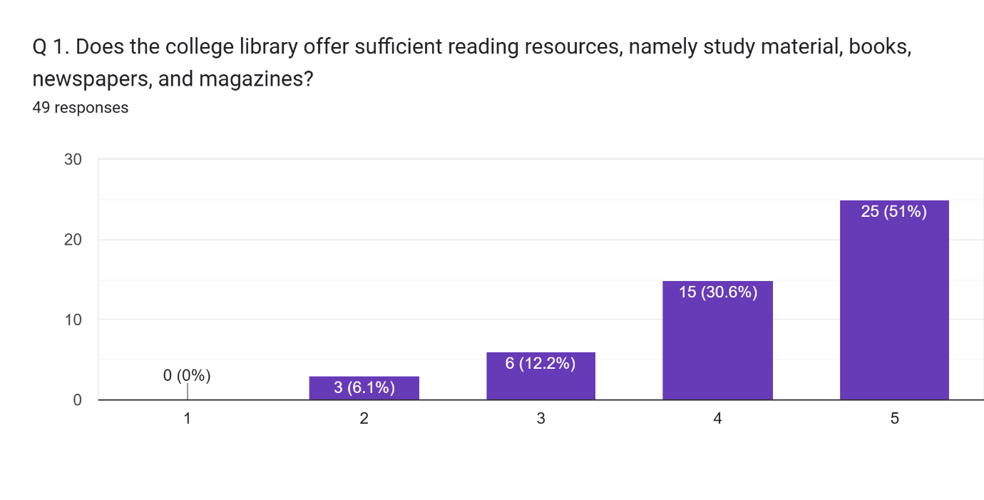

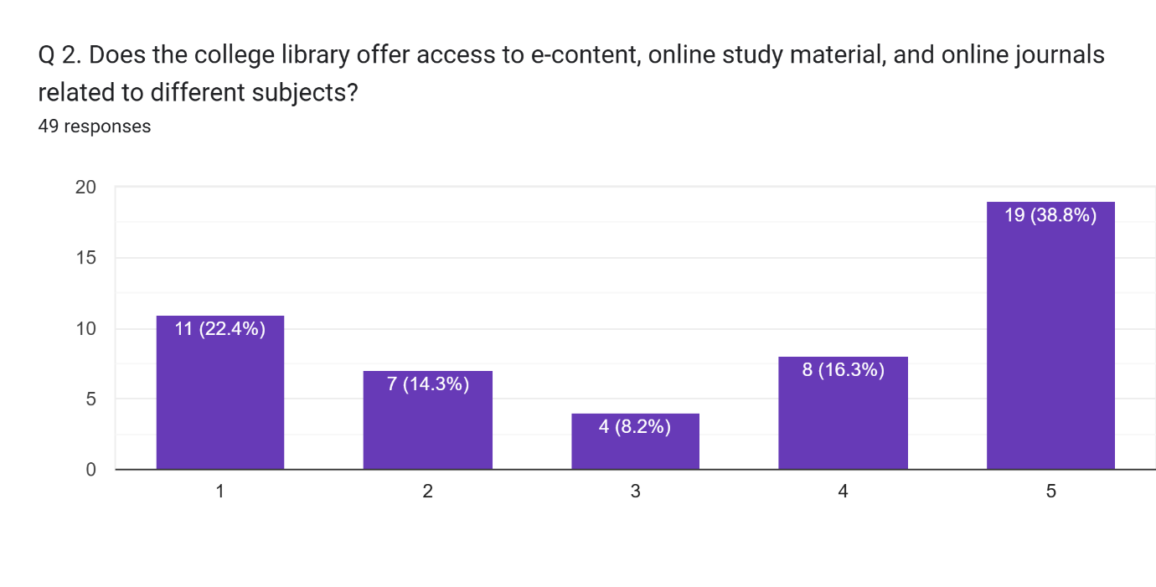

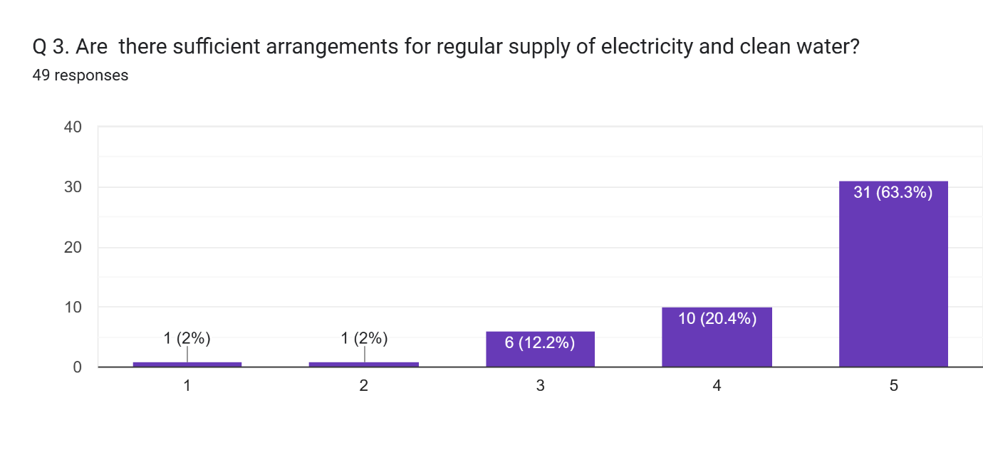

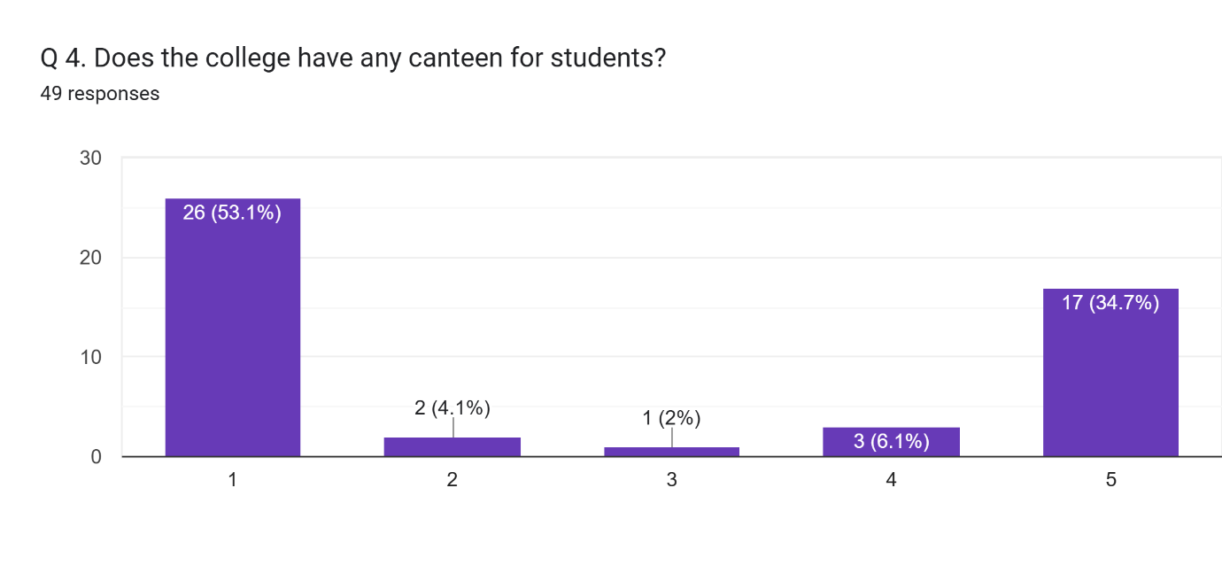

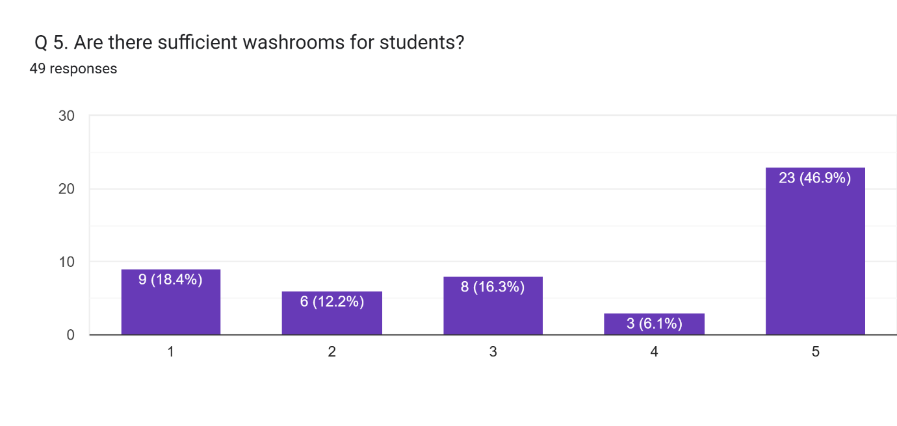

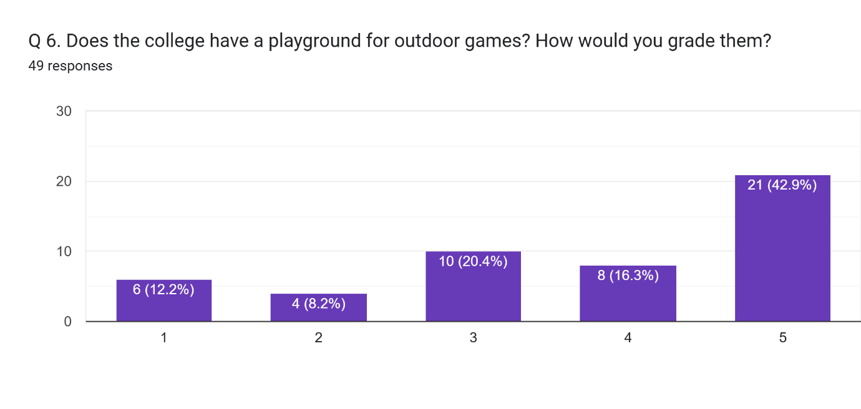

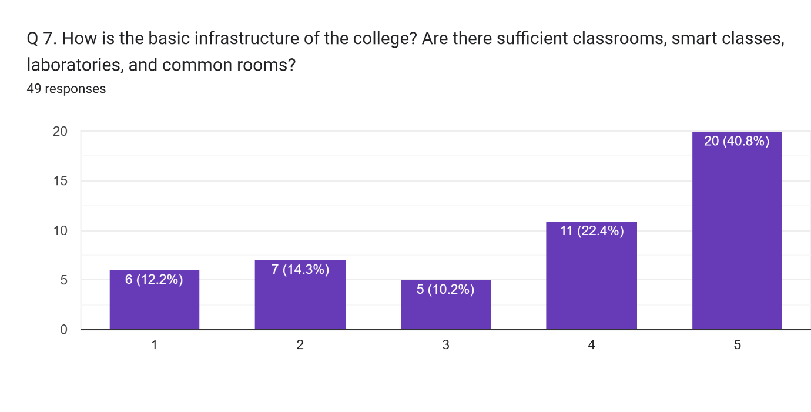

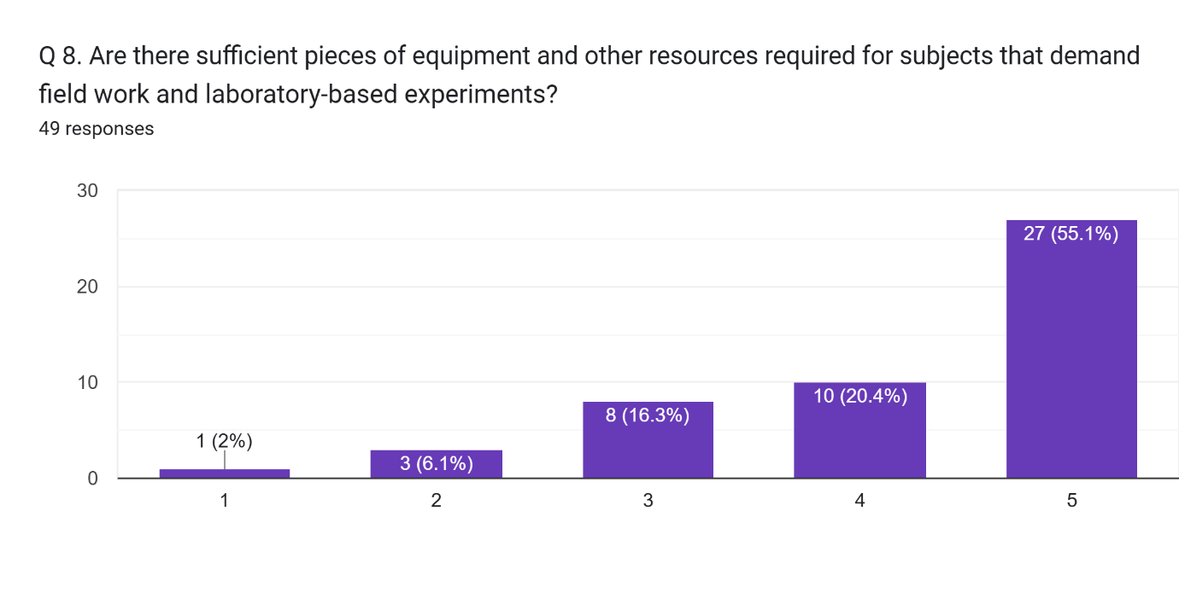

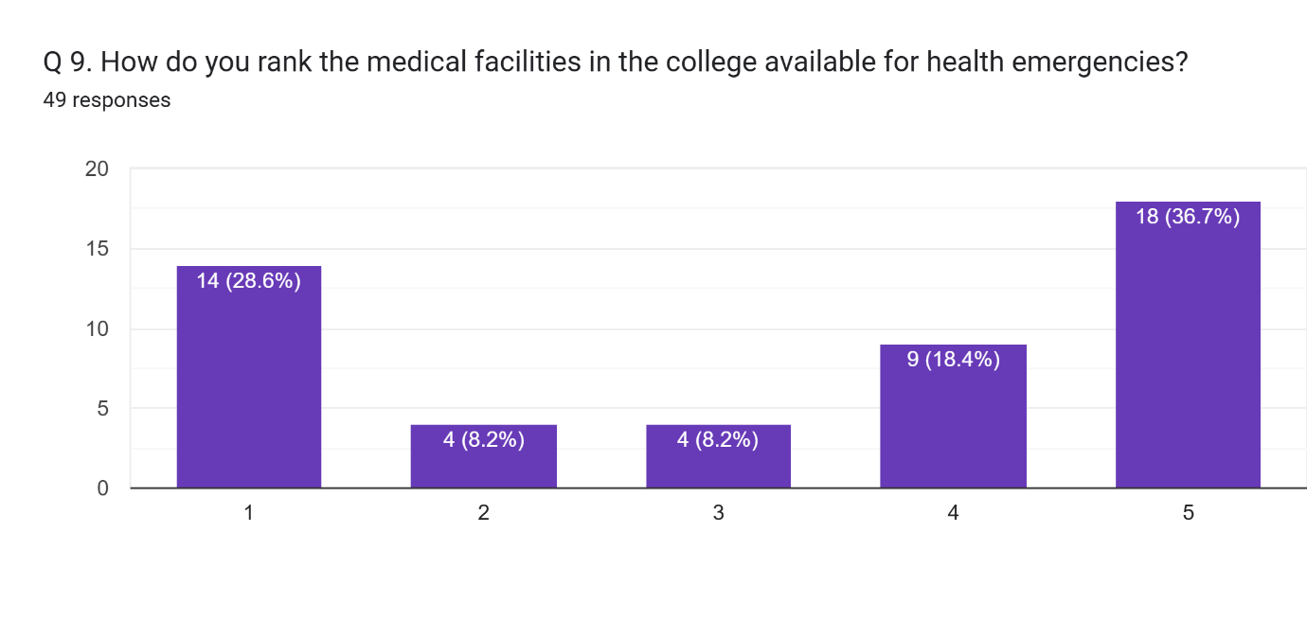

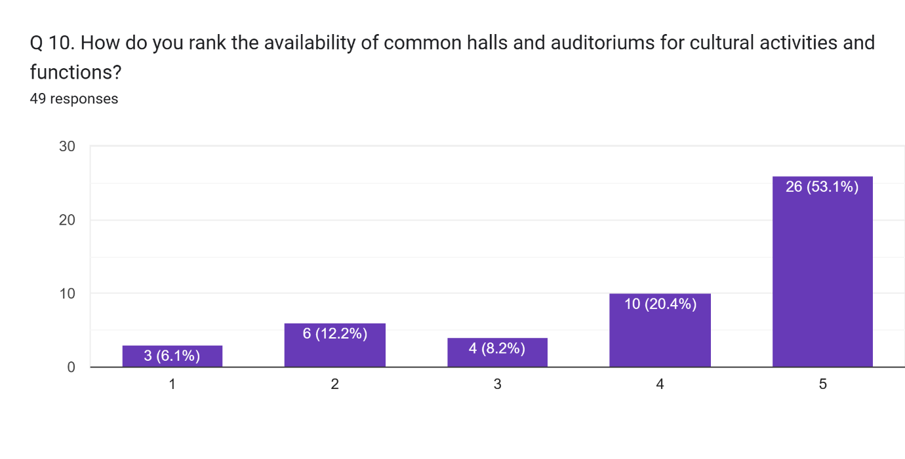

Any other comment which you would like to mention (Please write in space provided here).  
19 responses

Good

No

Study

Excellent

College need a all round development in faciliating the infrastructure in class room auditorium and play ground.

Nothing is better than nothing that is given

I am not selected in main campus of allahabad University but when I came Dr shyam Prasad Mukherjee PG College I experienced the world best facilities and teachers are here.. thank you so much my teachers and my College

Nhi

Campus se asantusht

Please run the class continuously without gapping.

Study

Not clean washroom and play ground

Online classes ki suvidha sanchalit kren

No comment

The playground in our college needs some attention