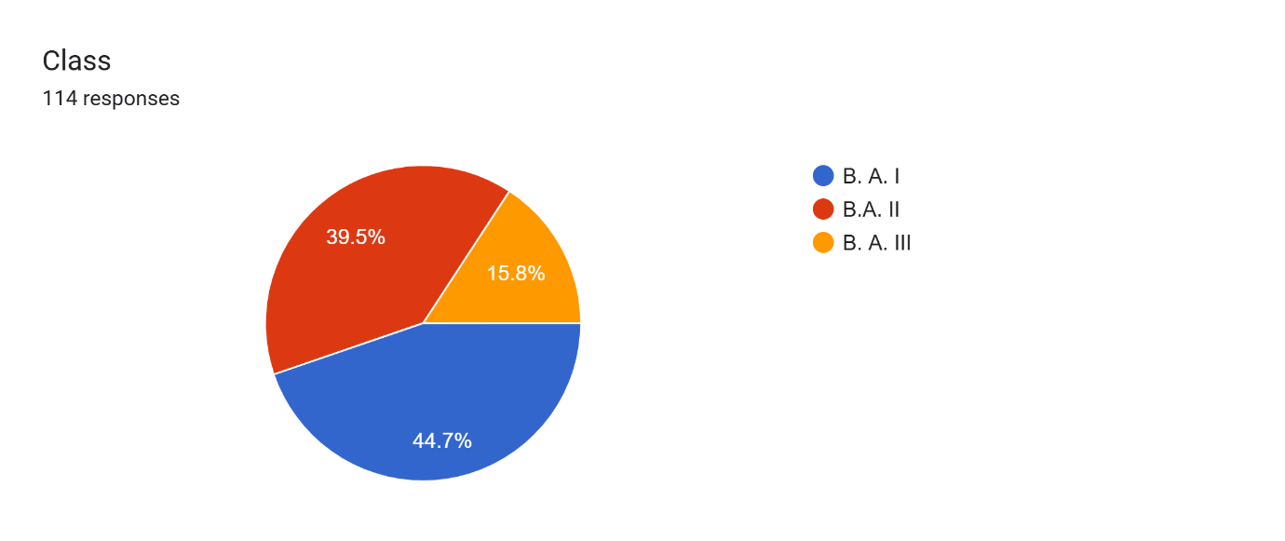

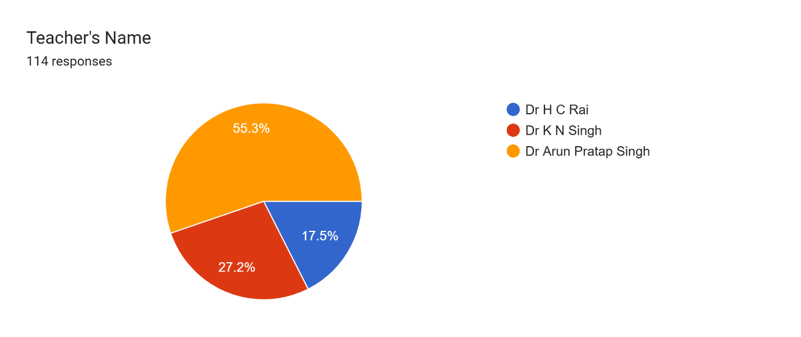

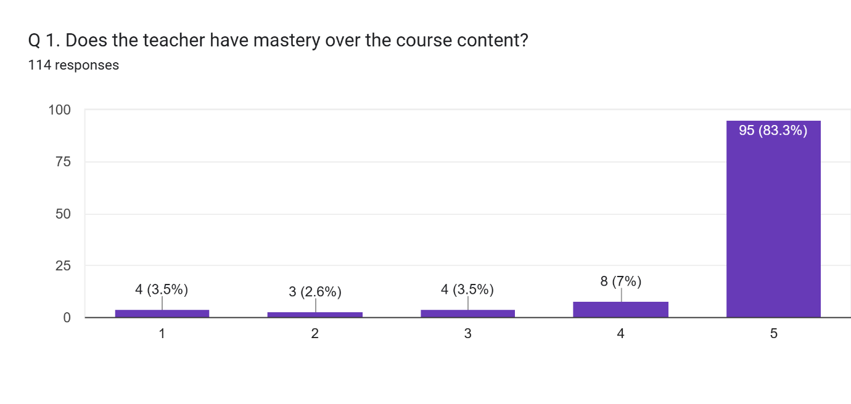

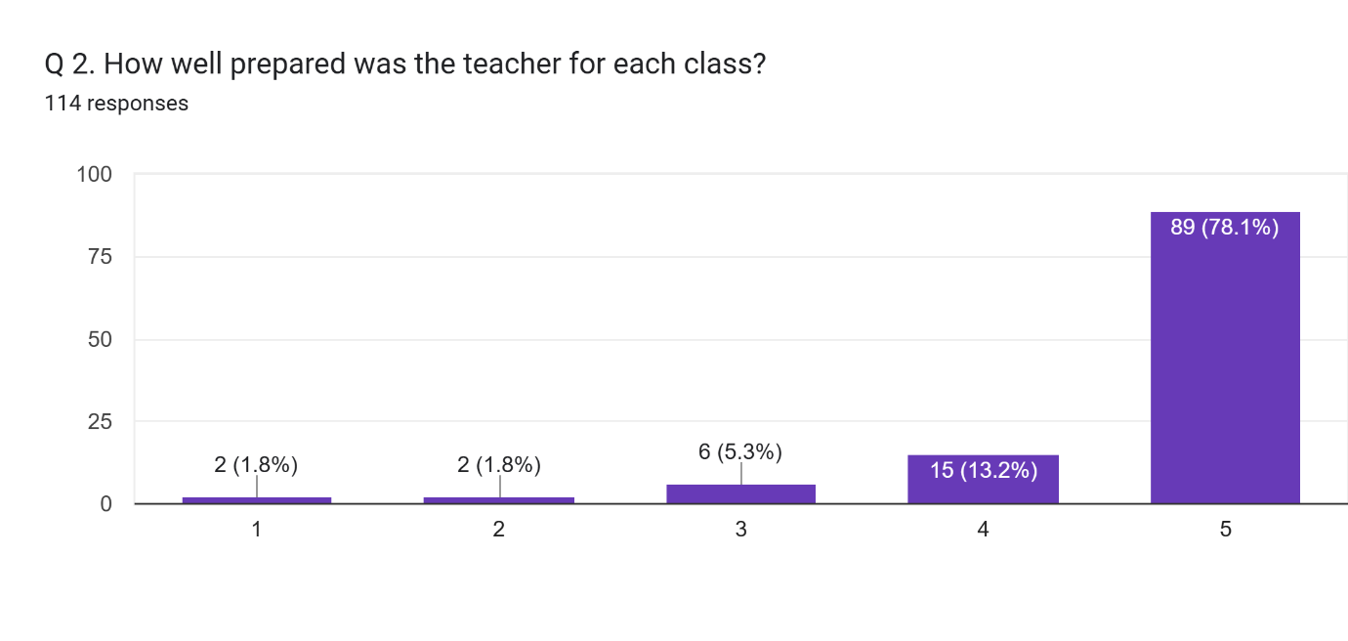

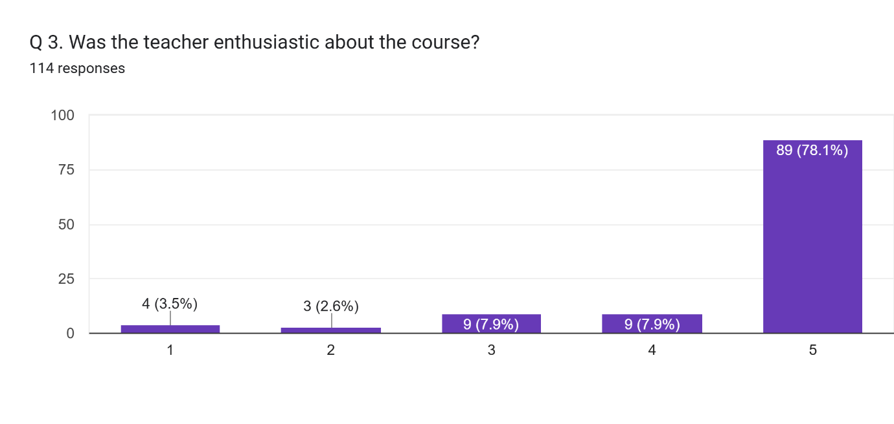

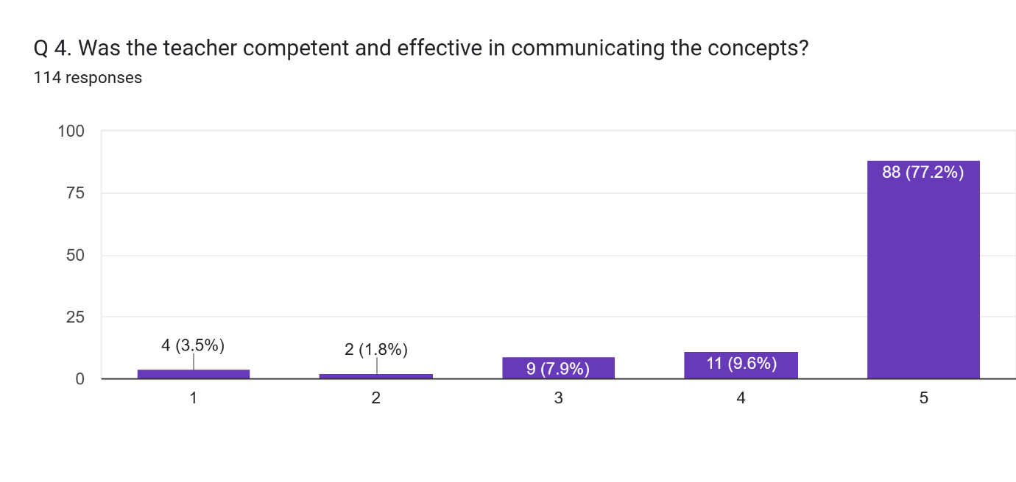

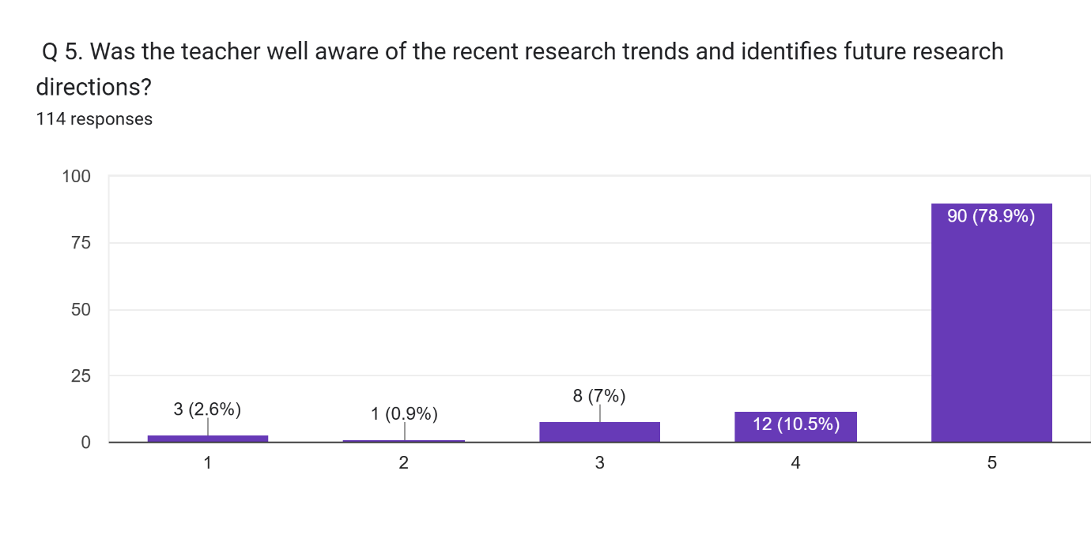

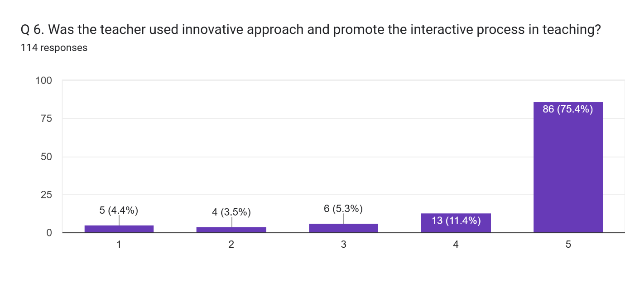

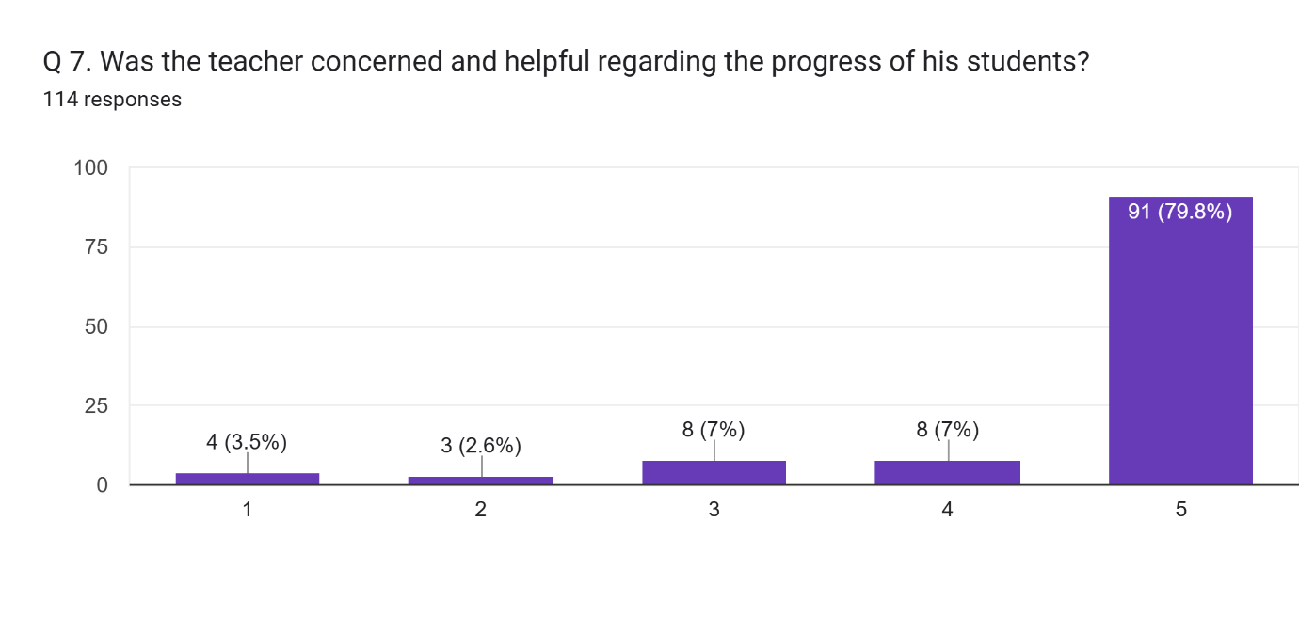

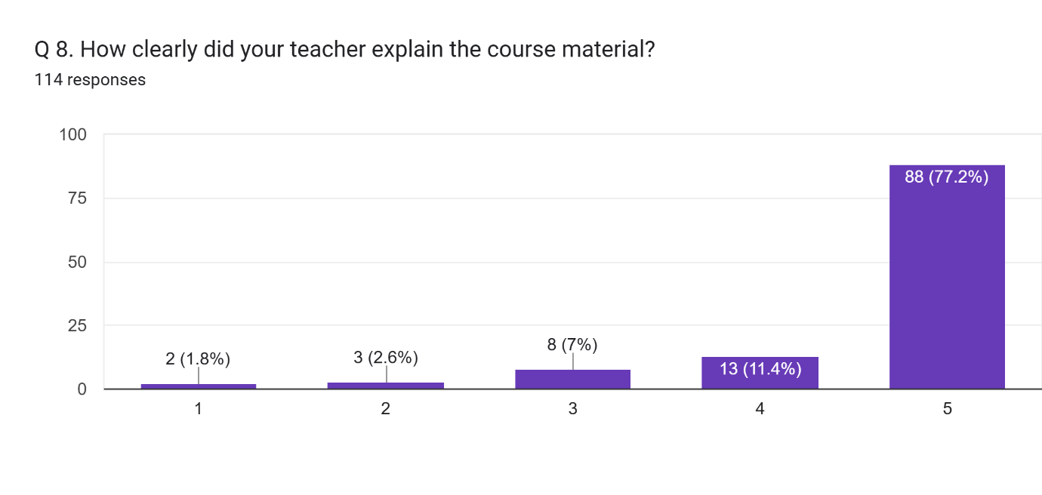

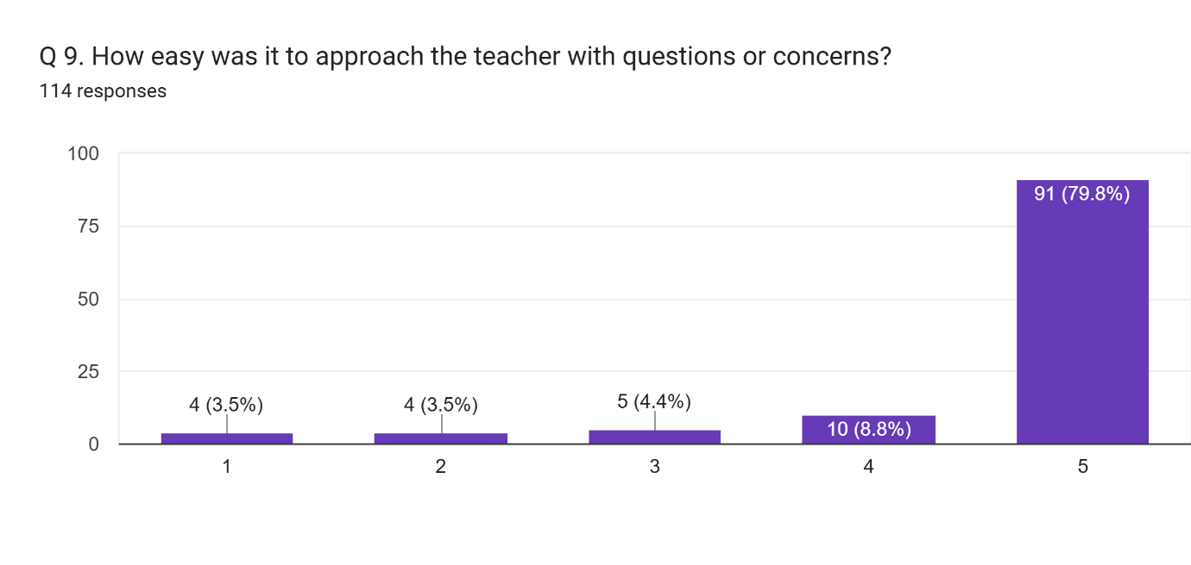

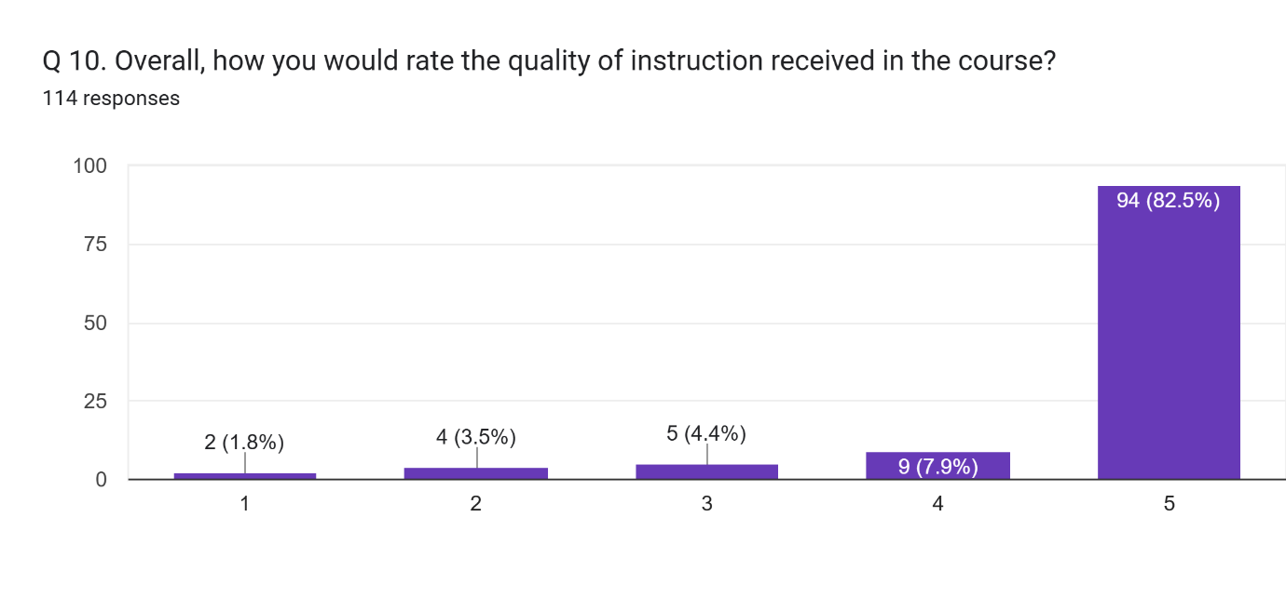

Any other comment which you would like to mention (Please write in space provided here).  
35 responses

Excellent

Nhi

Adarsh Mishra

Thank you for being a mentor, guide, and most importantly, a friend.

Thankyou

Arun sir is always friendly with us .. specially in geography practical survey he have a lots of patience with us .. we are very thankful to you sir .. you are our idea.

Good nature

Syllabus ko sahi decision Krna. Student ko simply aam bhasa me batana kisi bhi topic ko araam se batana vistar se point vise search one topic pr basic , all knowledge

Best teacher and mentor

Spm

Nice teacher and college

Arun sir is very good teacher

Thanks for lighting the path to knowledge

Need to understand that he is teacher and we are students not machine .

Best classes Sir

Okay

Arun Sir of Geography Department explains the concepts very well and treats the children politely.

All classes should run as per time and syllabus must be completed .

The class should be conducted properly and the syllabus should be completed

Need more attention towards taking classes always skip the class and very often teach us. While as a practical teacher he teaches us some how well.

Just speak and tell us to write while he speaks too fast that one can't write in so much speed .

Dr. K N Singh sir, very very brilliant Professor of the Geography, he always enthusiastic for teaching and he behaves friendly with students. Thanks very much, sir🙏🏻🙏🏻🙏🏻🥰

Satisfied

Study