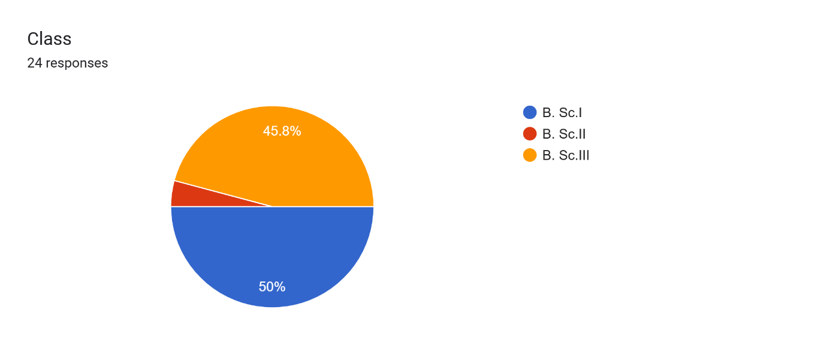

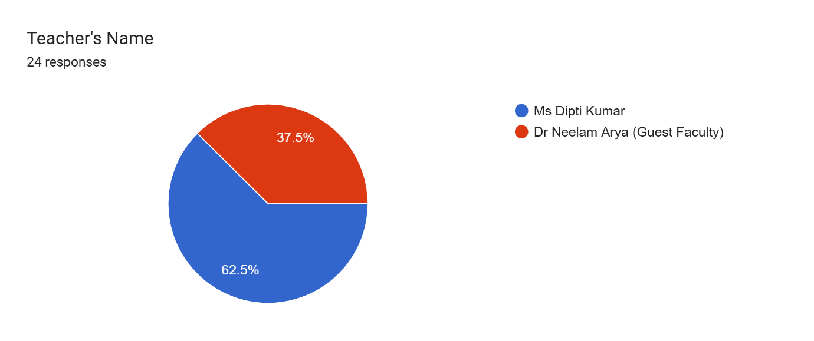

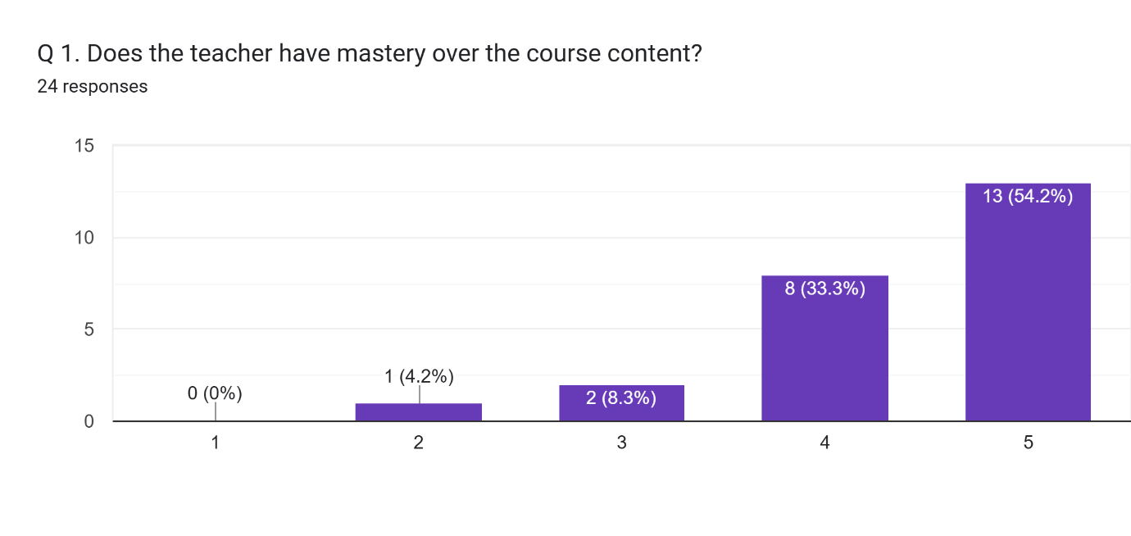

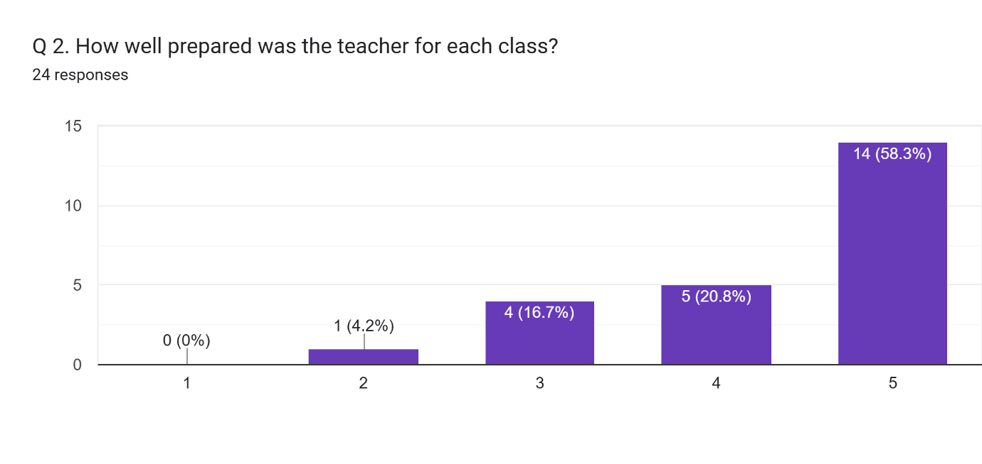

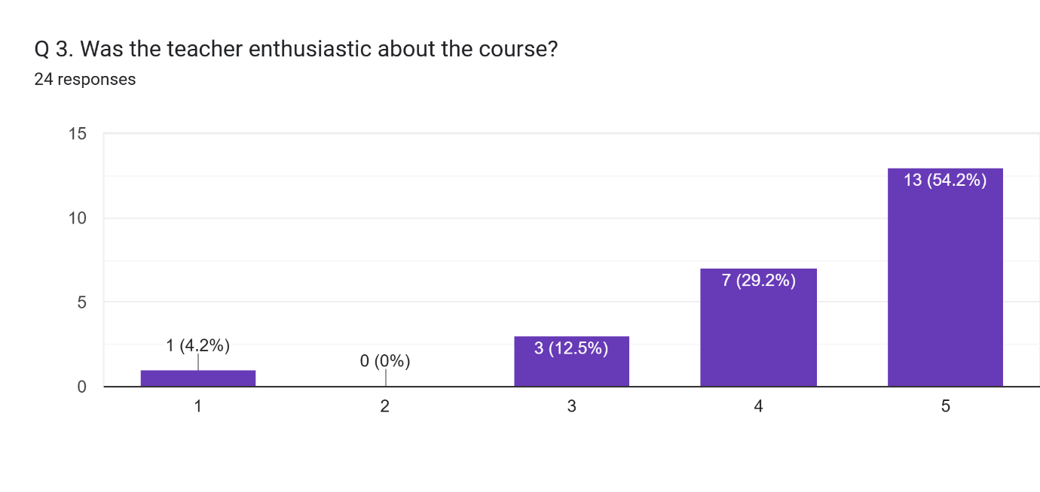

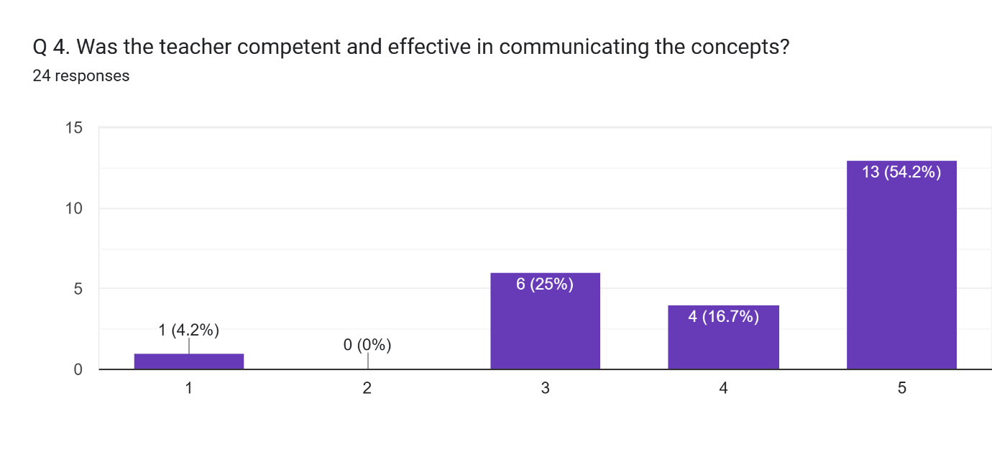

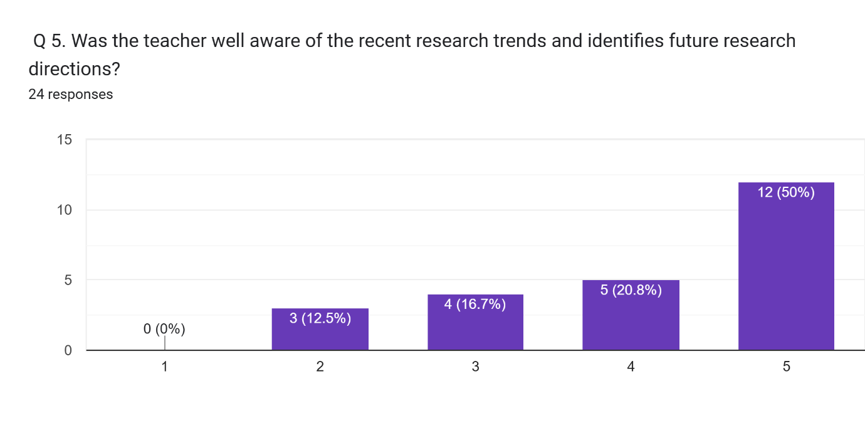

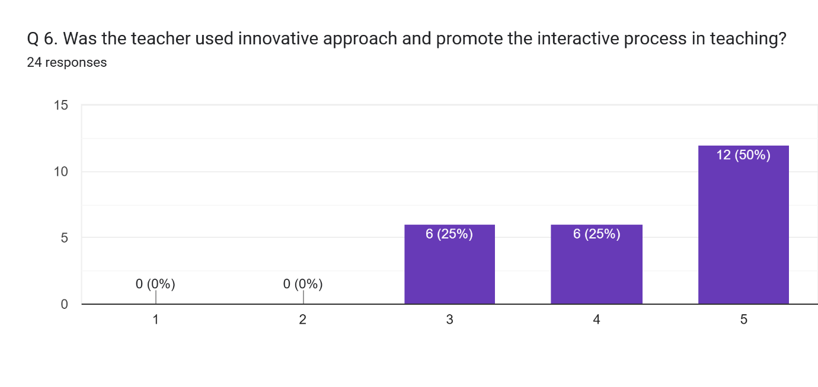

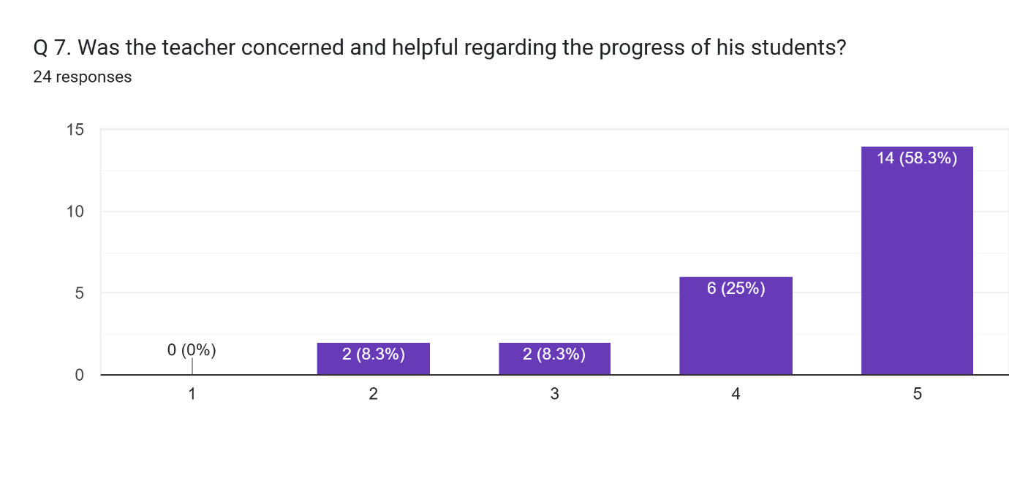

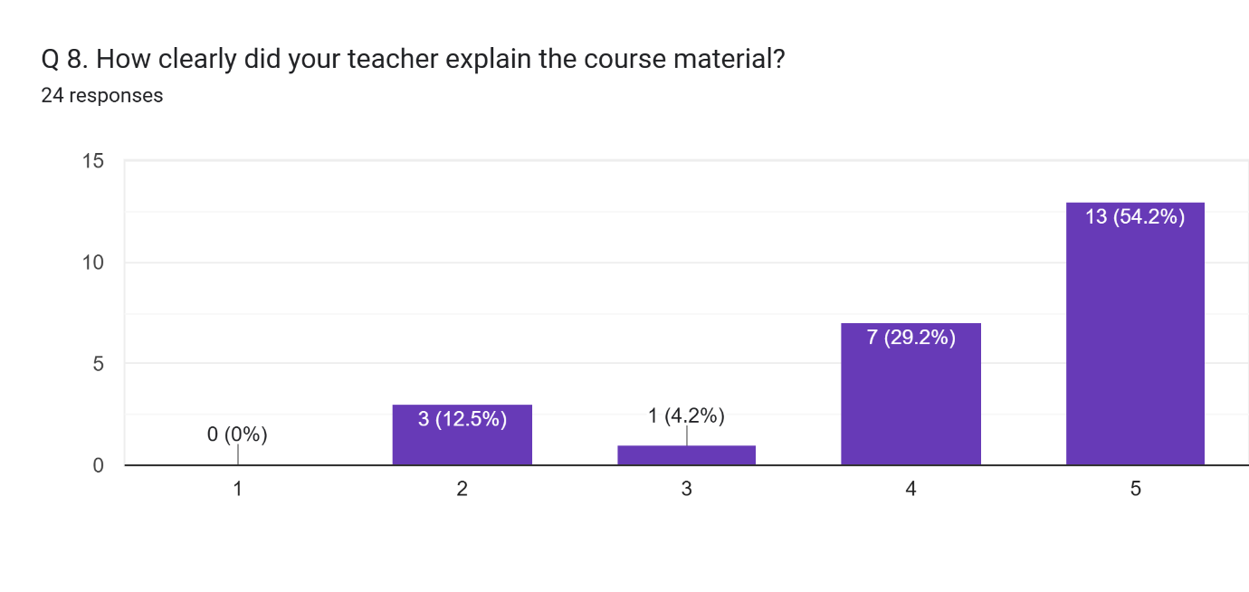

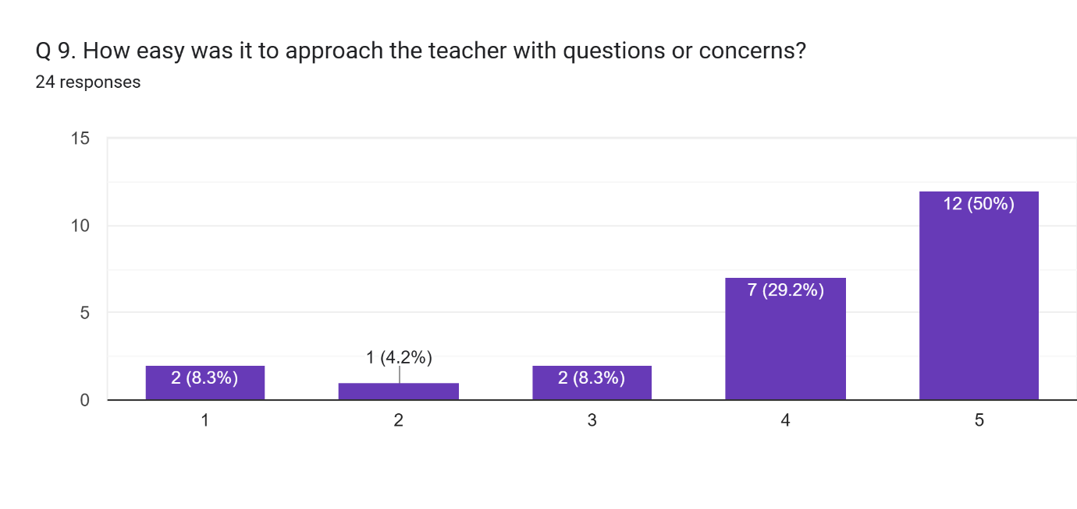

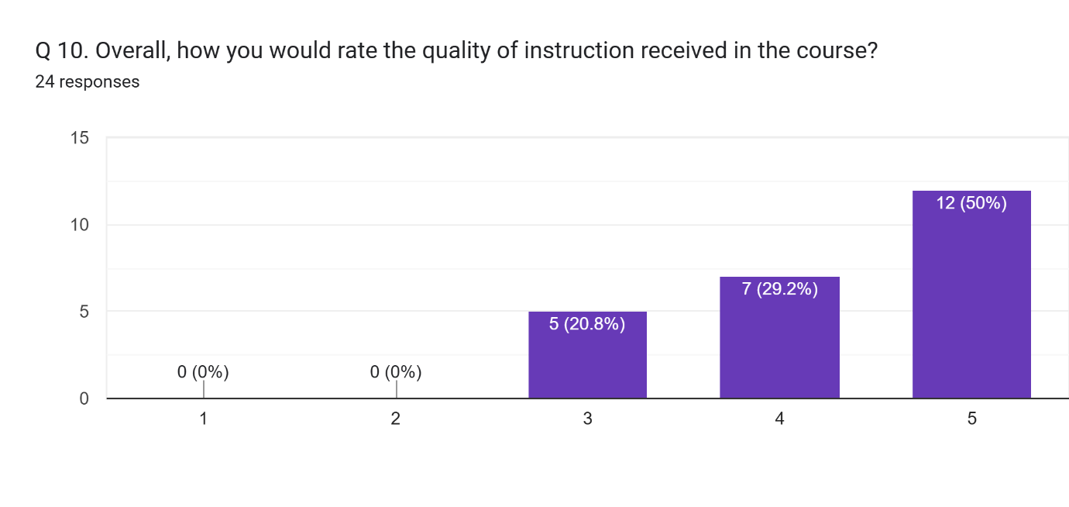

Any other comment which you would like to mention (Please write in space provided here).  
5 responses

I would only like to say that there should be more hands in botany department for helping our HOD i.e .Ms Dipti Kumar ma'am and there should be resources and materials as well because Ma'am has to bring the materials required for our practicals from her home.

I would like to say that botany department needs more hands for helping these two best teachers because our Neelam ma'am also has to bring materials required for our practicals from her home.

No

There was an joyful days which is we spend in botany lab

We enjoy our session