**Academic Session 2023-24**

**Students Feedback on Resources**

**Collected and Analyzed by Dr. Jharna Malviya**

**B.Sc.**

B.Sc. (Students Feedback on Resources)

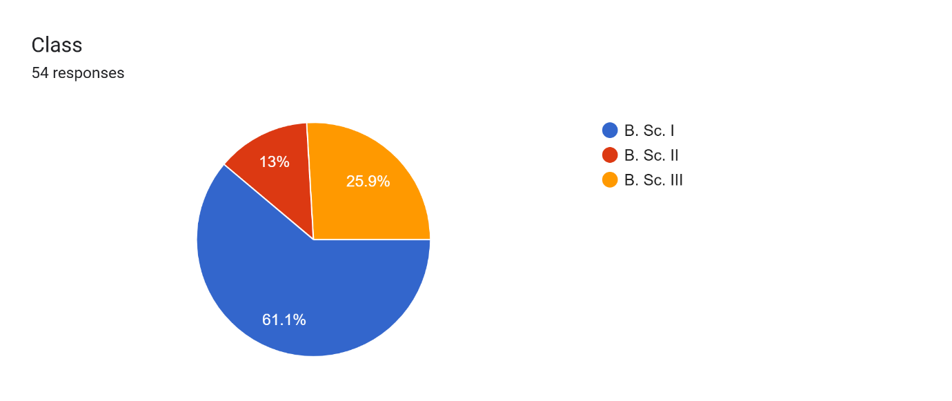

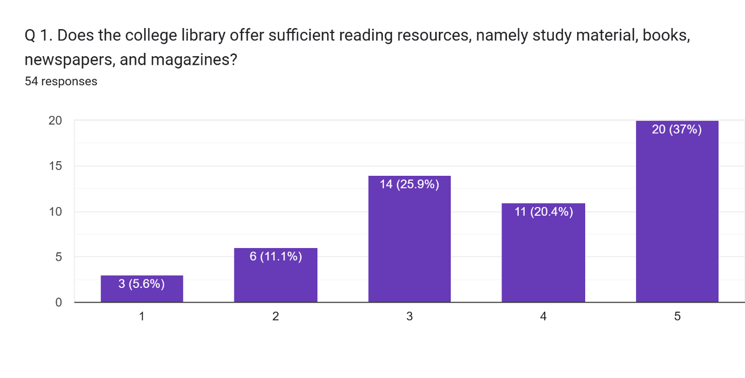

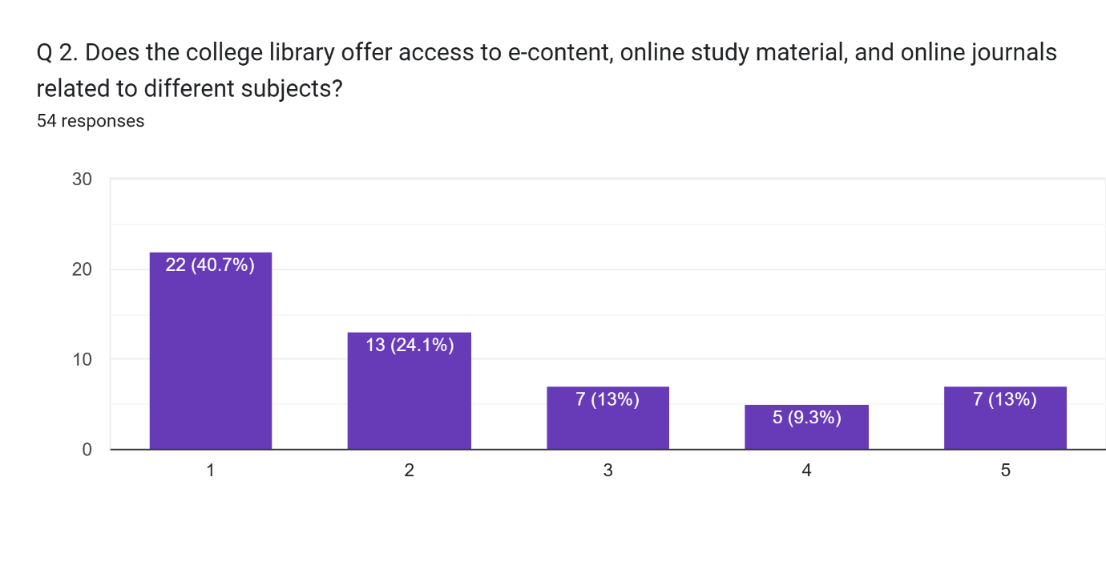

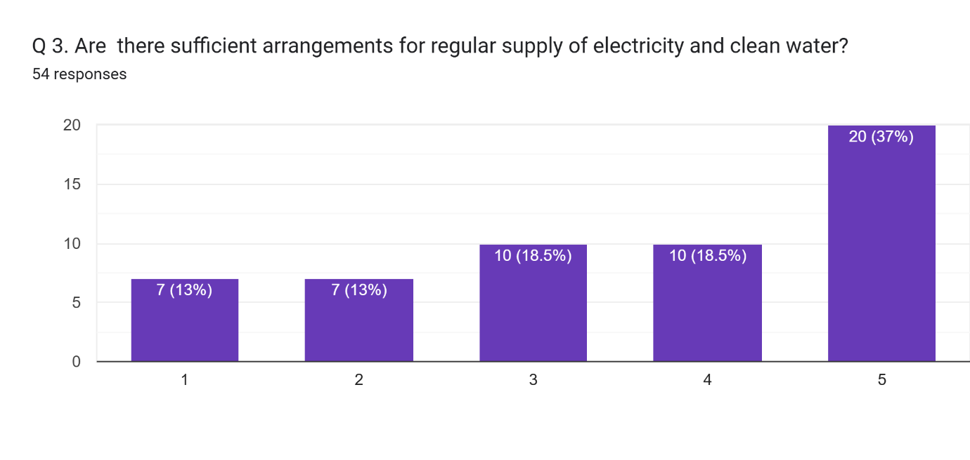

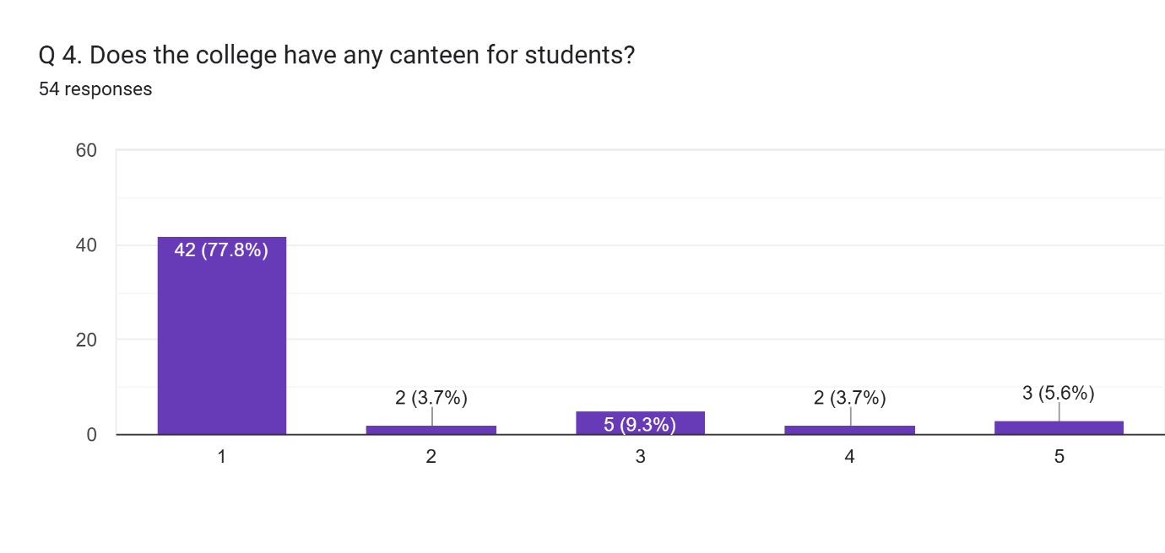

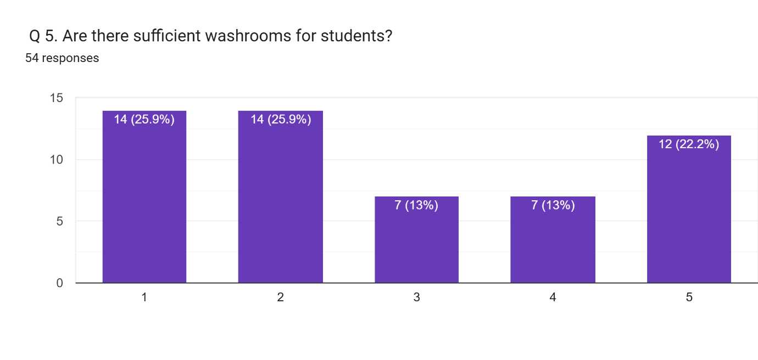

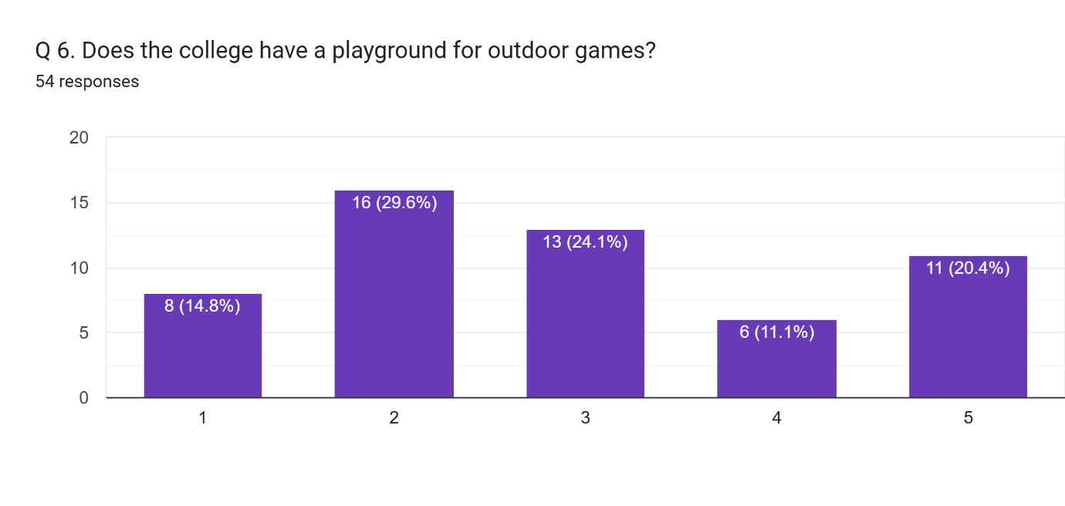

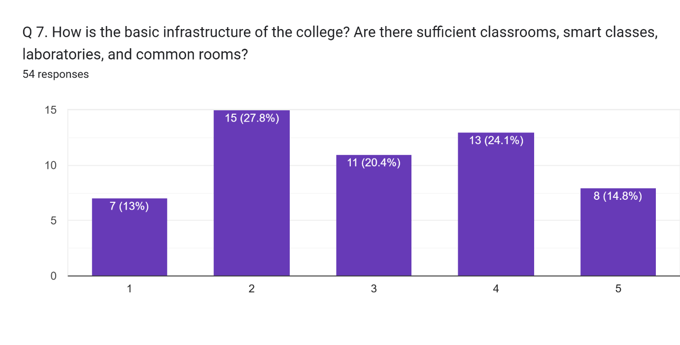

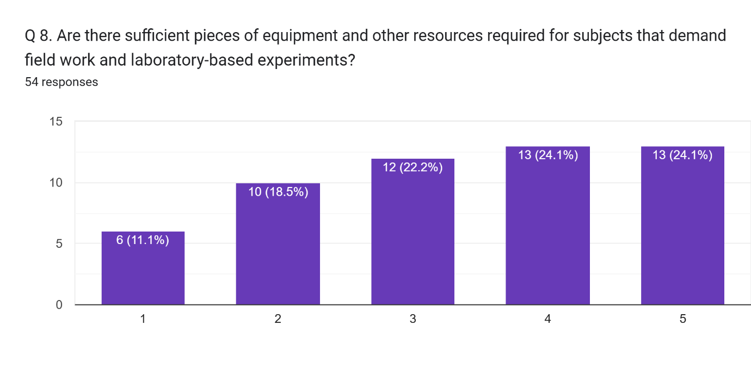

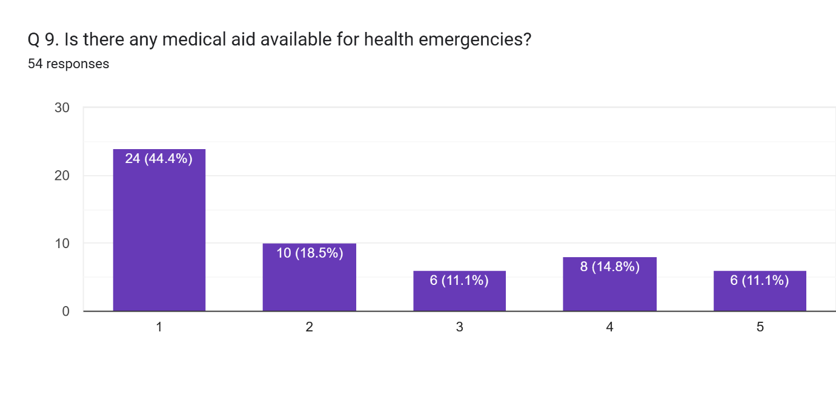

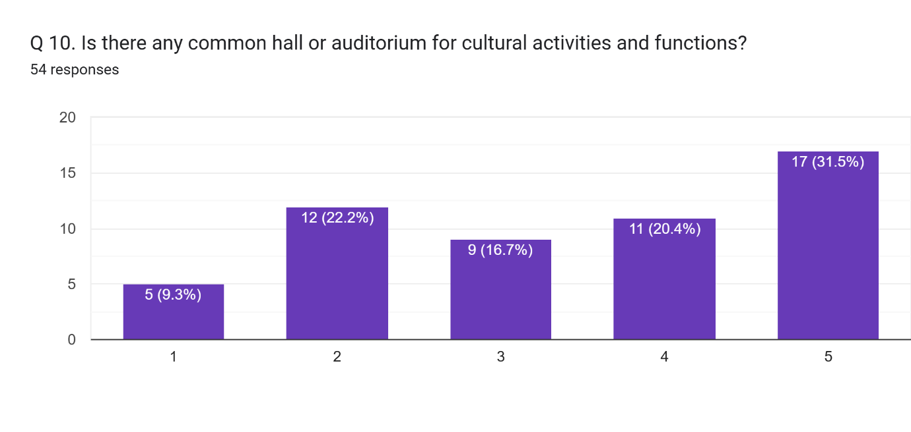

Any other comment which you would like to mention (Please write in space provided here).  
19 responses

No

..

Improve please

College should focus more on sanitation and cleanliness of washrooms and toilet . Proper water supply should be provided in the washrooms .

No canteen available in the college and the washrooms are not that hygienic to use

canteens should be provided

According to me as a student which I want is that to bring best books of science stream i.e. of the best and reputed writers because we does not get the books of those writers which our teacher's suggest in classroom but then also for studying we have to switch over to another writers .This problem in Library I faced alot in all the three years .This is my humble request to our principal ma'am to resolve this problem of library in SPM college so that our juniors gets the benefit of this thing 🙏

It requires a special attention toward tha canteen

Every teacher of college is best. Thanks.......

It needed special attention on the canteens..it's not available

Improve the college facility

Worse washroom i've ever used.

There's no canteen in the college, the condition of washroom is much worse than local's train.

Nothing

Better

Good

Washroom are not clean